Nama : Andri Firman Saputra  
NIM : 201011402125  
Kelas : 02TPLP023  
Tugas : Algoritma Pemrograman II – Pertemuan 6

**Hasil dari Program Penggajian Karyawan**

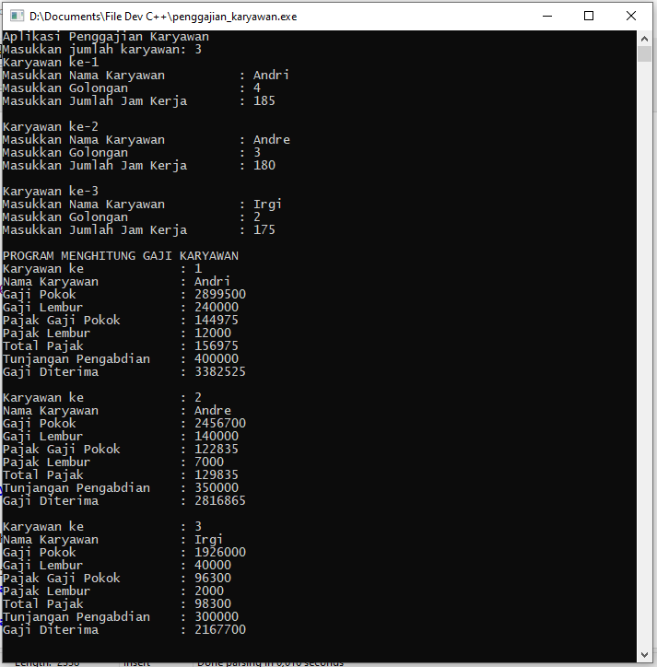

**Source Code:**

#include<iostream>

#include<conio.h>

#include<string>

using namespace std;

int main()

{

string nama_karyawan[10];

int jumlah_karyawan,

tunjangan_pengabdian[10],

jam_kerja[10],

jam_lembur[10],

golongan[10],

gaji_pokok[10],

gaji_lembur[10],

pajak_gaji_pokok[10],

pajak_gaji_lembur[10],

total_pajak[10],

gaji_bersih[10];

cout<<"Aplikasi Penggajian Karyawan"<<endl;

cout<<"Masukkan jumlah karyawan: ";

cin>>jumlah_karyawan;

for (int i = 1; i <= jumlah_karyawan; i++)

{

cout<<"Karyawan ke-"<<i<<endl;

cout<<"Masukkan Nama Karyawan \t\t: ";

cin>>nama_karyawan[i];

cout<<"Masukkan Golongan \t\t: ";

cin>>golongan[i];

cout<<"Masukkan Jumlah Jam Kerja \t: ";

cin>>jam_kerja[i];

switch (golongan[i])

{

case 1:

gaji_pokok[i] = 1486500;

tunjangan_pengabdian[i] = 250000;

break;

case 2:

gaji_pokok[i] = 1926000;

tunjangan_pengabdian[i] = 300000;

break;

case 3:

gaji_pokok[i] = 2456700;

tunjangan_pengabdian[i] = 350000;

break;

case 4:

gaji_pokok[i] = 2899500;

tunjangan_pengabdian[i] = 400000;

break;

default:

gaji_pokok[i] = 0;

tunjangan_pengabdian[i] = 0;

break;

}

if (jam_kerja[i] > 173)

{

jam_lembur[i] = jam_kerja[i] - 173;

}

else

{

jam_lembur[i] = 0;

}

gaji_lembur[i] = jam_lembur[i] * 20000;

pajak_gaji_pokok[i] = 0.05 * gaji_pokok[i];

pajak_gaji_lembur[i] = 0.05 * gaji_lembur[i];

total_pajak[i] = pajak_gaji_pokok[i] + pajak_gaji_lembur[i];

gaji_bersih[i] = (gaji_pokok[i] + tunjangan_pengabdian[i] + gaji_lembur[i] - total_pajak[i]);

cout<<endl;

}

cout<<"PROGRAM MENGHITUNG GAJI KARYAWAN"<<endl;

for (int i = 1; i <= jumlah_karyawan; i++)

{

cout<<"Karyawan ke \t\t: "<<i<<endl;

cout<<"Nama Karyawan \t\t: "<<nama_karyawan[i]<<endl;

cout<<"Gaji Pokok \t\t: "<<gaji_pokok[i]<<endl;

cout<<"Gaji Lembur \t\t: "<<gaji_lembur[i]<<endl;

cout<<"Pajak Gaji Pokok \t: "<<pajak_gaji_pokok[i]<<endl;

cout<<"Pajak Lembur \t\t: "<<pajak_gaji_lembur[i]<<endl;

cout<<"Total Pajak \t\t: "<<total_pajak[i]<<endl;

cout<<"Tunjangan Pengabdian \t: "<<tunjangan_pengabdian[i]<<endl;

cout<<"Gaji Diterima \t\t: "<<gaji_bersih[i]<<endl;

cout<<endl;

}

getch();

}